20.49: a) ab: For the isothermal process, 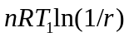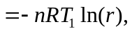 and 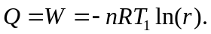bc: For the isochoric process, cd: As in the process ab, 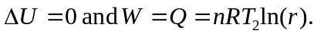da: As in process bc, 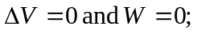 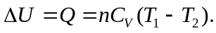 b) The values of Q for the processes are the negatives of each other. c) The net work for one cycle is 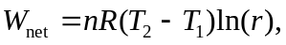and the heat added (neglecting the heat exchanged during the isochoric expansion and compression, as mentioned in part (b)) is 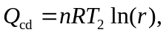 and the efficiency is 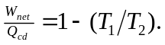 This is the same as the efficiency of a Carnot-cycle engine operating between the two temperatures.

